EENG 3920: Modern Communication Systems Design

# Lab 2: Frequency Spectra of Popular Waveforms

Group 5

Victor Rodriguez (victorcuba92@gmail.com)

Mohammad Qawash (MohammadQawash@my.unt.edu)

John Rolfe (JohnRolfe@my.unt.edu)

Natalie Powers (NataliePowers@my.unt.edu)

Nathan Ruprecht (nathan.ruprecht@outlook.com)

**Date of Submission: 18 February 2016**

**Section 1**

**Introduction and Learning Objective**

EENG 3920 is the project design course for electronics courses. Students are required to design electronic communication systems with electronic devices such as MOS transistors, capacitors and resistors. The design and simulation tool is NI ELVIS platform. Topics include LC circuits and oscillators, AM modulation, SSB communications, and FM modulation.   At the end of the class, the student should be able to: Understand fundamental concepts and circuits used in communication systems; Describe principles and theory of various communication techniques such as AM, FM, and SSB; Conduct effective analysis and interpretation of the experiments; Demonstrate the ability to identify, analyze, and solve technical problems; Creatively apply the course topics to designs; Simulate and analyze advance electronics circuits with NI ELVIS instruments and other test equipment.

For this experiment we become acquainted with the Fourier series and its use in representing the frequency spectra of signals commonly used in communication systems. We use our knowledge in analyzing frequency response of ceramic filters and the spectrum analysis.

**Safety guidelines**

            As mentioned in the lab procedures, safety is extremely important in the lab. In the event of electrical fire, the session 1 lecture note states to use the fire extinguisher, located at the front of the lab, then to vacate the lab, close the door and ring the fire alarm.

**Section 2 / 3**

**Theoretical Background**

Fourier series is utilized to explain how signals are filtered processed within various blocks and stages that is the core of communication systems. It can also be expressed that the Fourier series can be utilized as a mathematical tool to represent any periodic function in terms of sinusoidal waves as a series of sine and cosine functions.  Those waveforms can be expressed in various ways, the most popular being the sinusoidal as it is the easiest way to represent a waveform mathematically. Other waveforms can be represented by either square or triangle waves. The Fourier series of any wave form can be known by its spectral content and can be expressed in a spectrum diagram. The spectrum diagram can be shown as a series of multiple individual harmonics with amplitudes representing the voltage with respect to frequency.

**Basic Instruments**

            The basic instruments we used in this lab were the breadboard, oscilloscope, frequency counter, spectrum analyzer, and waveform generator.  For the components we use a ceramic filter (Murata-Erie CFM 455A) as well as a couple of 0.5 watt 1.5K ohm resistor.

**Exercises**

Procedure:

For the first part of the exercise we built the circuit shown in figure 2-3 of the lab manual using the CFm-445 D ceramic filter and connect our circuit input to the wave function generator and the output of it to the oscilloscope to observe the maximum output voltage. We started the input frequency at 455 KHz and fine-tuned it to obtain the max output voltage. After measuring the peak values of the input and output voltages we calculated the insertion loss of the filter and recorded the gain on Table 1 - Results.

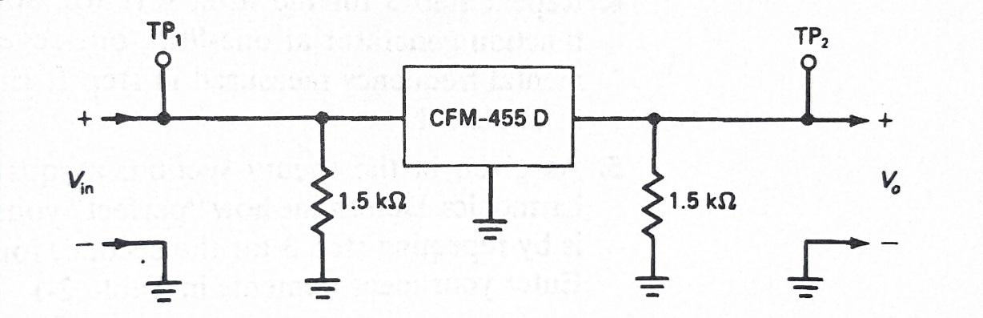

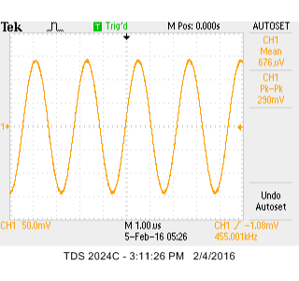

Fig 0-1

For the second part of our exercise we set the function generator to produce a 5 Volt amplitude and we start our frequency at 455 KHz. This time we switched the wave form to a square waveform on the oscilloscope. We also fine tune the frequency on the generator to get the maximum voltage output and recorded the frequency and loss insertion to calculate the gain as shown in Table 1 – Results. We repeat the steps to find the peak value of the harmonics but instead of retuning the ceramic filter to resonate the given harmonic frequency, we set the function generator and adjust it to the right frequency for any given harmonic for example the third harmonic would start at the frequency of one-third of the original 455 KHz and then fine tune it to record our frequencies and peak values for each harmonic and record our data on Table 1 – Results.

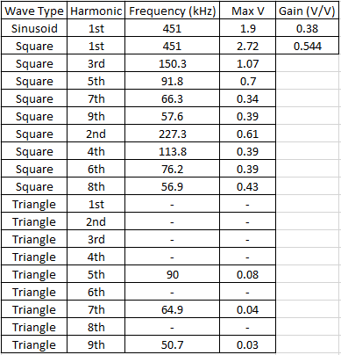

Table 1 – Results

A major problem we found was when we tried to apply a triangle wave using the function generator.  Right from the beginning, we found out that we could not go higher than 200 kHz which eliminated the first two harmonics.  Trying to work our way down the list of harmonics at the certain frequencies, the output signal was a flat line giving us nothing.  The odd harmonics after five started to give us some results, but it was still unclear what was going wrong.  Other groups did have similar problems as well as our instructor being unsure.

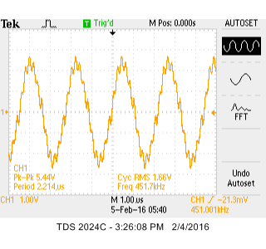

Fig. 1 – First harmonic at

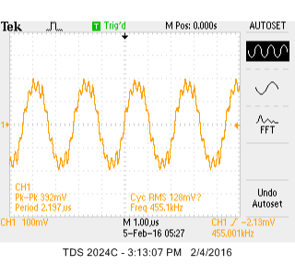  
Fig. 2

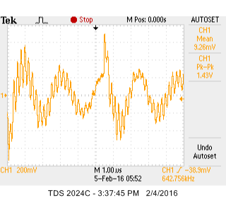

Fig. 3 5th harmonic

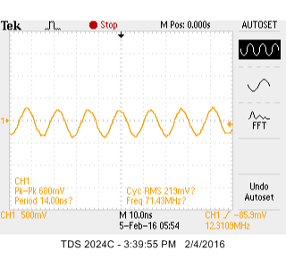

Fig.4 7th harmonic

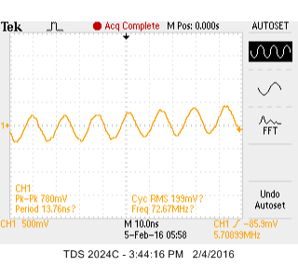

Fig.5 9th harmonic

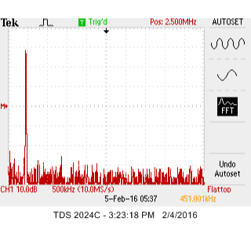

**Section 4**

**Conclusion**

In this lab we experienced first-hand the frequency response to a low pass filter by observing the voltage outputs at each harmonic. We did hit a wall (as did most groups) when using the triangle wave. Limited to a maximum 200 kHz on the function generator as well as no output at most harmonics restricted us from further analysis. Professor Agbor tried to help us out but also seemed to have some problems.

**References**

Agilent Technologies, 2007, *Agilent 34401A 6 ½ Digit Multimeter, User’s Guide*.